**4CS015 – Portfolio Task #4**

**STUDENT NAME**: Manogya Harsha Bajracharya

**STUDENT NUMBER**:np03cs4a220129

You will need to complete the workshop and then submit this Word file, complete with your answers, via Canvas, by the end of Semester (week 12).

For this assignment (workshop) you will show you how to navigate and create file systems from command prompt in both Windows (os) and Linux(os), also how to create a batch file to be executed in the Windows (os).

**NOTE: Please make sure you have written your command as well as the screenshot of the commands. Failure to do so will result in marks deduction.**

# Task 1 (Windows Command Line)

1. Write a command to Create a directory "**test**"

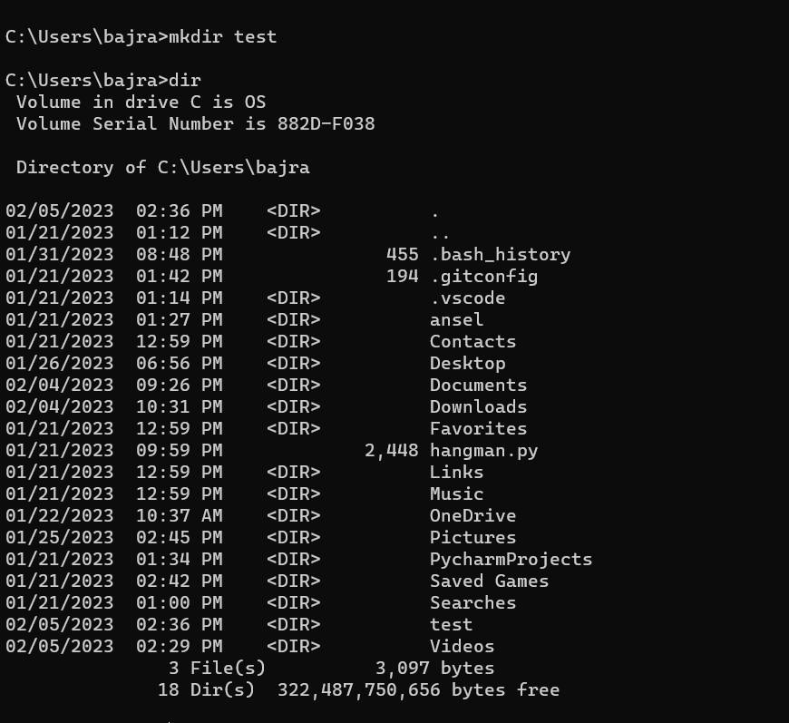

1. Write the command to list all the directories/files inside the directory **test**

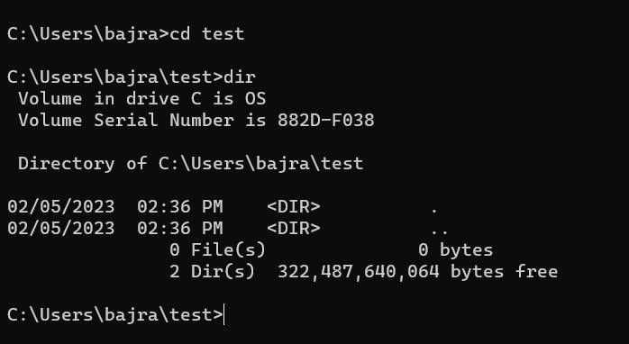

1. Create a file "**hello.txt**" containing the word "Hello", inside the test directory.

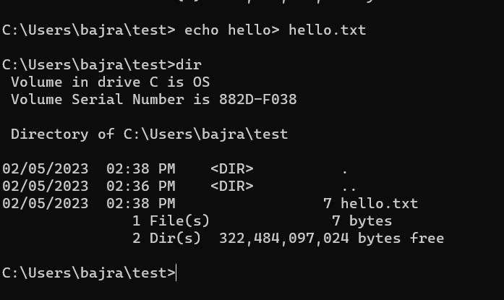

1. Display the content of **hello.txt** in the command line.

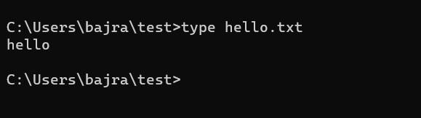

1. Make directory **test1** in the Desktop and copy **hello.txt** from **test** to **test1**

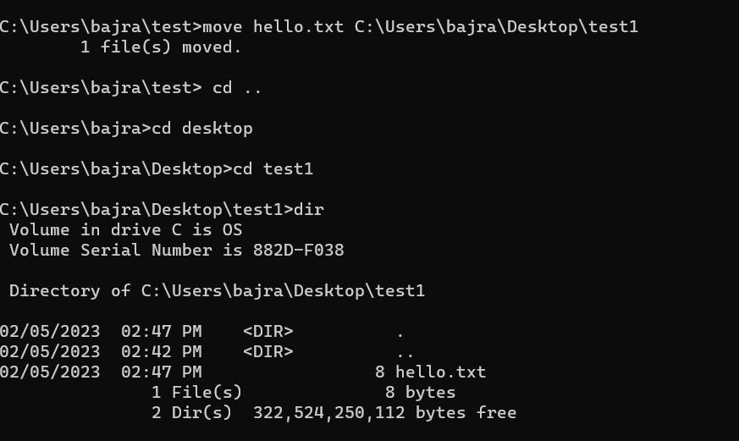

1. Now delete the file **hello.txt** in the current directory

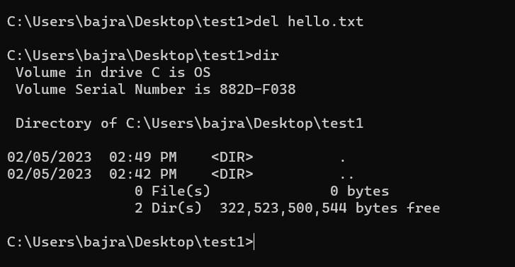

1. Write a command to display your current directory.

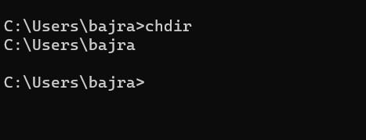

1. Now rename the file to **hello2.txt**

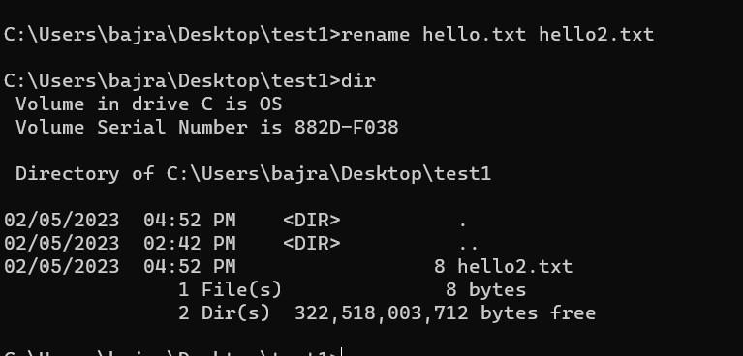

1. Now navigate outside the directory test.

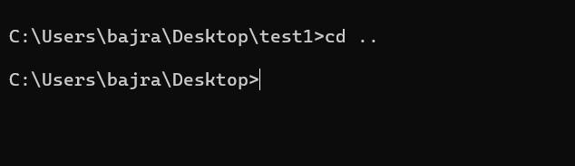

1. Write the command to print the tree structure. It should look something like this:

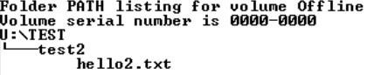

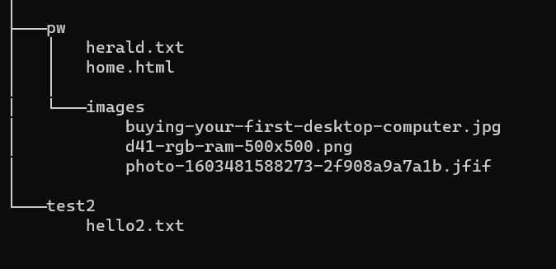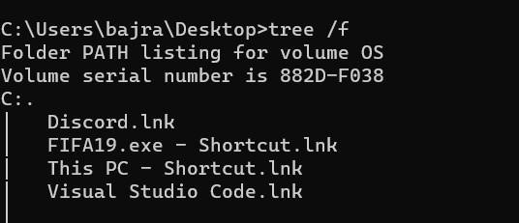

# Task 2

Create the following directory structure and paste it after this picture. (15 marks):

**Note: MYMODULES must be inside <your_name> directory.**

**Make a directory with your name on the desktop and navigate to the directory before you display the following structure.**

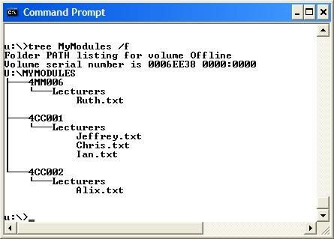

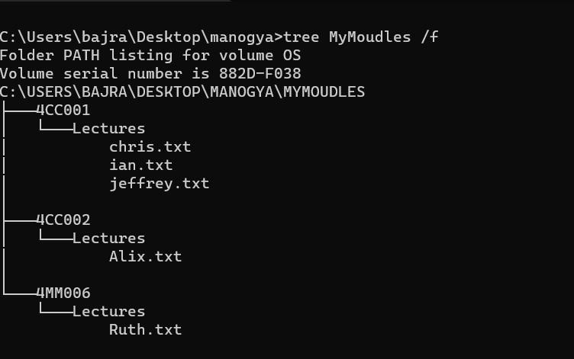

# Task 3(Linux terminal) (10 marks)

Now, Boot into Linux operating system in virtualbox or Windows-SubSystem for LInux(On Windows) 1. Write a command to Create a directory "**test**"

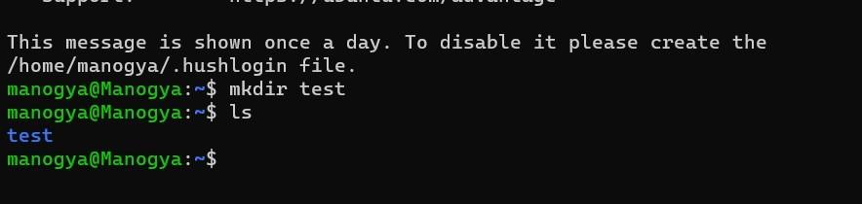

1. Write the command to list all the directories/files inside the directory **test**



1. Create a file "**hello.txt**" containing the word "Hello", inside the test directory.

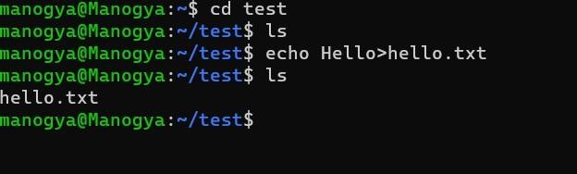

1. Display the content of **hello.txt** in the command line.

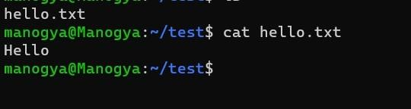

1. Make directory **test1** in the Desktop and copy **hello.txt** from **test** to **test1**

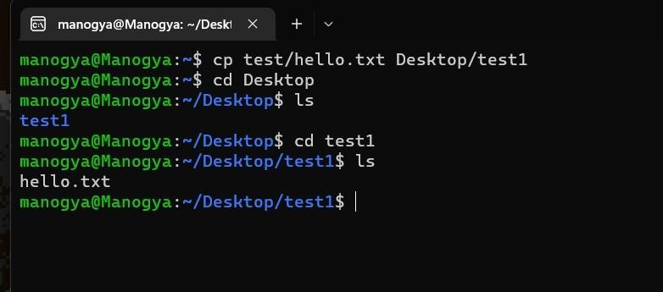

1. Now delete the file **hello.txt** in the current directory

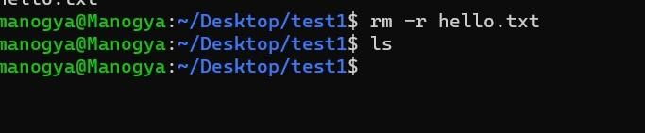

1. Write a command to display your current directory.



1. Now rename the file to **hello2.txt**

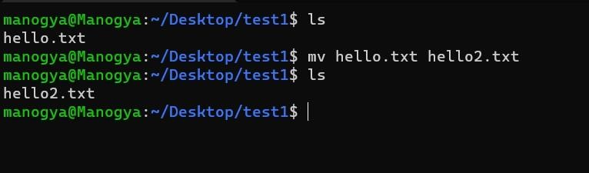

1. Now navigate outside the directory test.

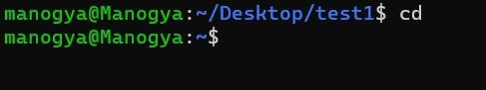

1. Write the command to print the tree structure.

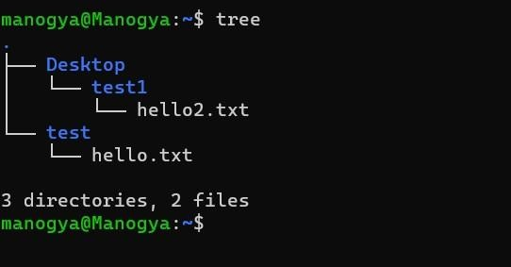

# Task 4

Create the following directory structure (identical to the one that you created in Windows Command Prompt):

**Note: MYMODULES must be inside <your_name> directory.**

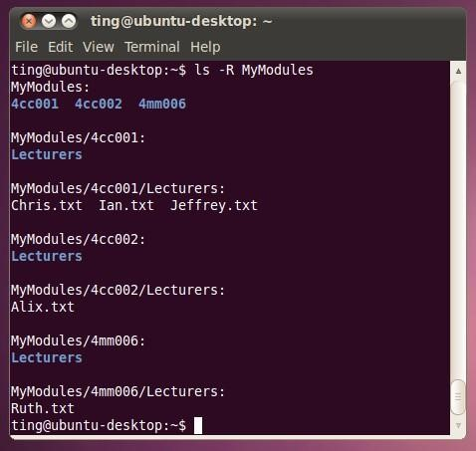

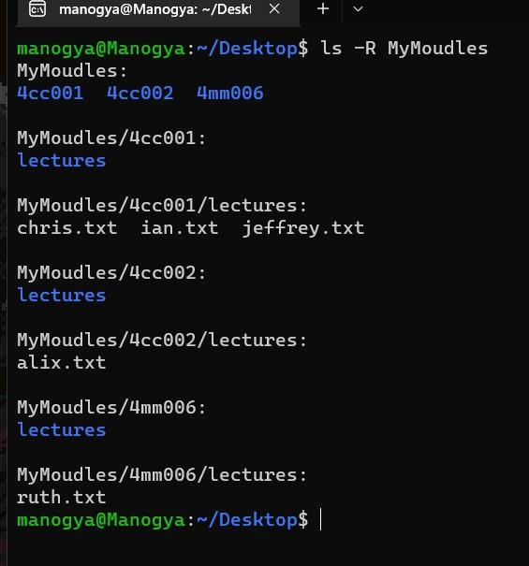

# Task 5

**Batch file material (50 marks in total)**

Create a batch file (windows) **YourNumber.bat** from notepad (or your preferred text editor). Create this program on your home drive (or portable drive – USB) ready for execution.

The batch file should create a directory structure similar to the one create for the first section of this assignment but the directory entries should be provided from an input request from the batch file itself.

You should be able to create a root directory and directory structure and populate it if required. The batch file program will ask for names (**input directory names and file names**) to be used and have some form of **error checking** (empty – incorrect character, length, etc.) You can add other features such as being able to edit the new structure from within the batch file program (**find and change a directory name**).

Run batch file from windows prompt: YourNumber.bat <enter>

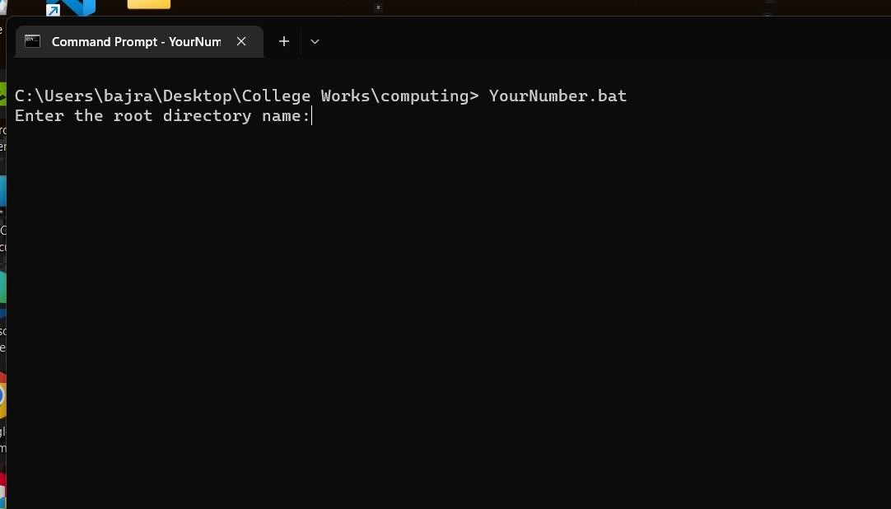

|  |
| --- |
| @echo off |
|  |
| :input |
| set /p root=Enter the root directory name:  if "%root%"=="" ( |
| echo Error: invalid name |
| goto input |
| ) |
|  |

[Insert your picture(s) here] – Directory structure created / menu of batch file (inputs and output when batch file is executed) (10 marks)

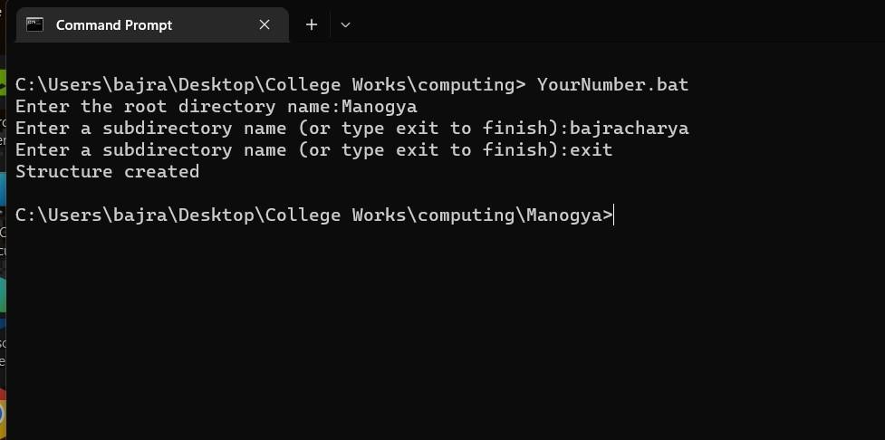

[Insert your text here] – batch file listing (script)(40 marks)

|  |
| --- |
| @echo off  :input set "root=" set /p root=Enter the root directory name:  if not defined root ( echo Error: invalid name goto input  )  md "%root%" 2>nul cd %root% :subdir set "subdir=" |
| set /p subdir=Enter a subdirectory name (or type exit to finish):  if not defined subdir ( echo Error: invalid name goto subdir  ) if "%subdir%" == "exit" ( cd .. echo Structure created exit /b  ) md "%subdir%" 2>nul cd %subdir% goto subdir |